Introduction Video
Name: ________________________________________________Class_______________

Do the following items and check them off when they are complete.

_____ 1. Log In with your user name and Password. If it doesn’t work use guest or guest 1.

_____ 2. Insert a disc with the pictures.

Find your teacher’s folder
Find your folder and drag it to your desktop.
From there you can put it in your house.

_____ 3. Open “I-movie and begin a new project.

_____ 4. Insert your pictures.

Go to File and down to “import”

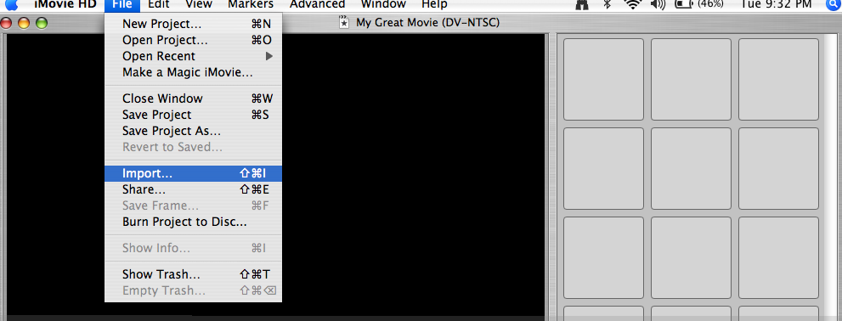

Click on desktop or your house depending where you have your pictures.
Find Lincoln5-6pics,
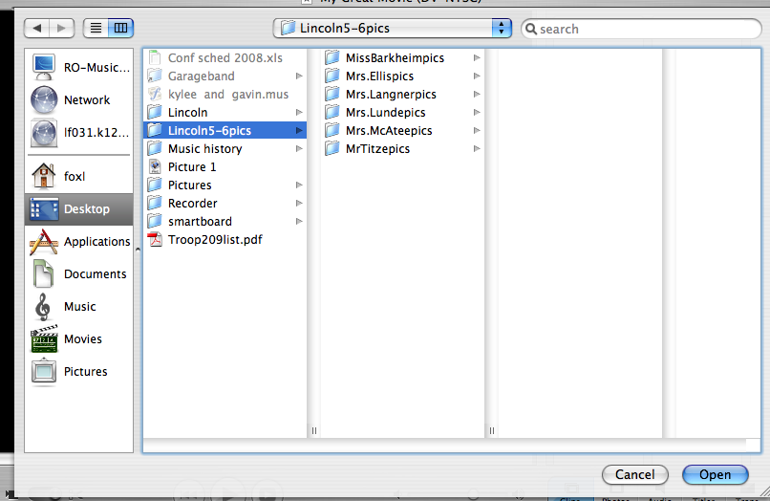
Click on your teacher’s name and then on your name.
Highlight all of your pictures and then click open.
They should load into your imovie.
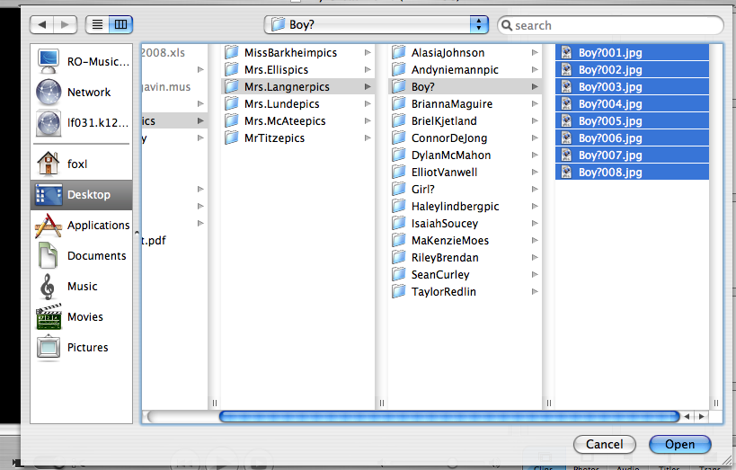

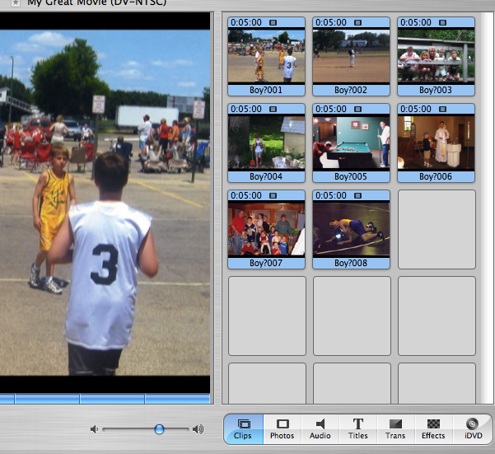
SAVE YOUR WORK!! MAKE SURE IT HAS YOUR NAME AND CLASS.

_____ 5. Drag your pictures to the time line. Increase the time to 8 instead of 5.
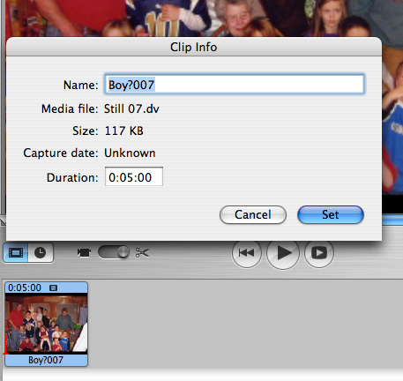
Double click on the pictures
Click behind the 5 and delete and type in 8
Click set.

_____ 6. Add a black title to the beginning and add titles to and pictures you want. These can
be on the picture or on a black page before the picture.

SAVE YOUR WORK!! MAKE SURE IT HAS YOUR NAME AND CLASS
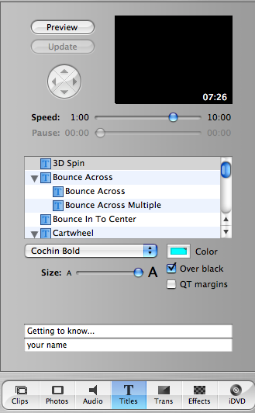
Click on the word Title.
Write what you want the title to say.
Choose on of these actions for the words and drag this in front or on your picture
Change the word color if you wnat
Change speed too.

_____ 7. Add transitions between each pictures.

SAVE YOUR WORK!! MAKE SURE IT HAS YOUR NAME AND CLASS
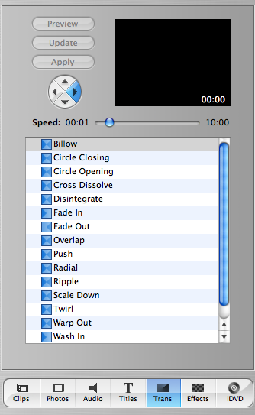
Click here for transitions.
Change speed here too
Choose one of these and drag it between you pictures.

_____ 8. Add audio.
Put your CD into the computer
When you click on audio you should be able to select your disc.
Find the song you want to add.
Make sure your play head is at the beginning.
Click “Place at play head”

SAVE YOUR WORK!! MAKE SURE IT HAS YOUR NAME AND CLASS
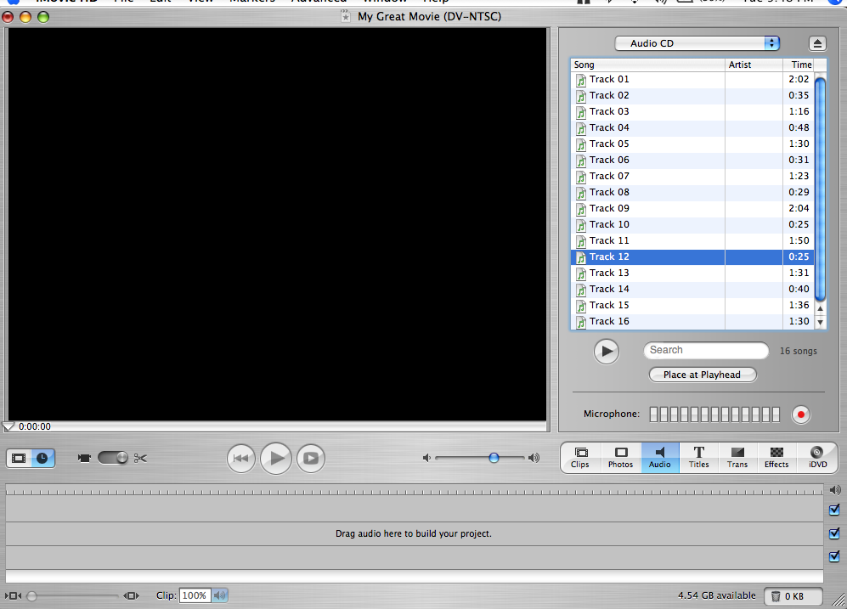
Click on the dial to put in your music.
Here is where you click.!!

_____ 9. Edit your song.
Find the part you want to keep. Move the play head to that spot.
Go to edit and then to split audio clip at play head.
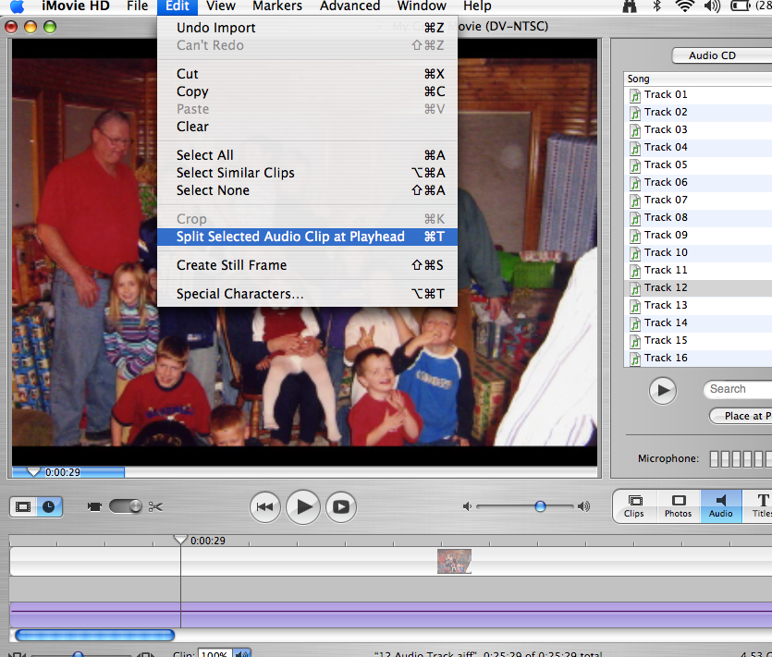
Play head is right here.
Make sure the part you want deleted is dark purple and then press delte.
SAVE YOUR WORK!! MAKE SURE IT HAS YOUR NAME AND CLASS.

_____ 10. Take a look.
Go to the beginning of the movie and press either play button.

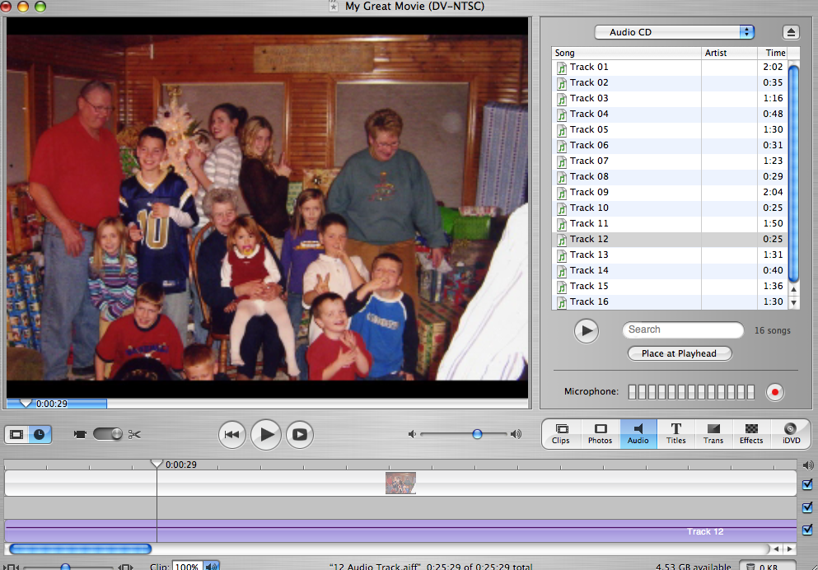
These to are both play buttons. The big one plays like it is now and the little one on the right makes it big screen.
Click here to go to the beginning of the movie.

_____ 11. Go back to any section to make changes to the parts you don’t like.

SAVE YOUR WORK!! MAKE SURE IT HAS YOUR NAME AND CLASS

Enjoy!

